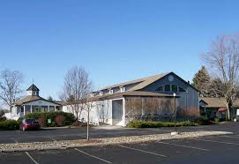
The MARC Foundation invites you to take part in this exciting event. Proceeds will support the crucial work of Mid-Hudson Addiction Recovery Centers, Inc., helping individuals and families find the path to recovery from alcoholism and other drug addictions with the following:
Chemical Dependency Crisis Center
Provides emergency services to men and women who are in crisis because of chemical dependency.
Florence Manor
Community Residence for Women
Bolger House
Community Residence for Men
Dowling House
Community Residence for
Men and Women
Sober Supported Housing
Provides supportive services and rent subsidies as resident’s transition.

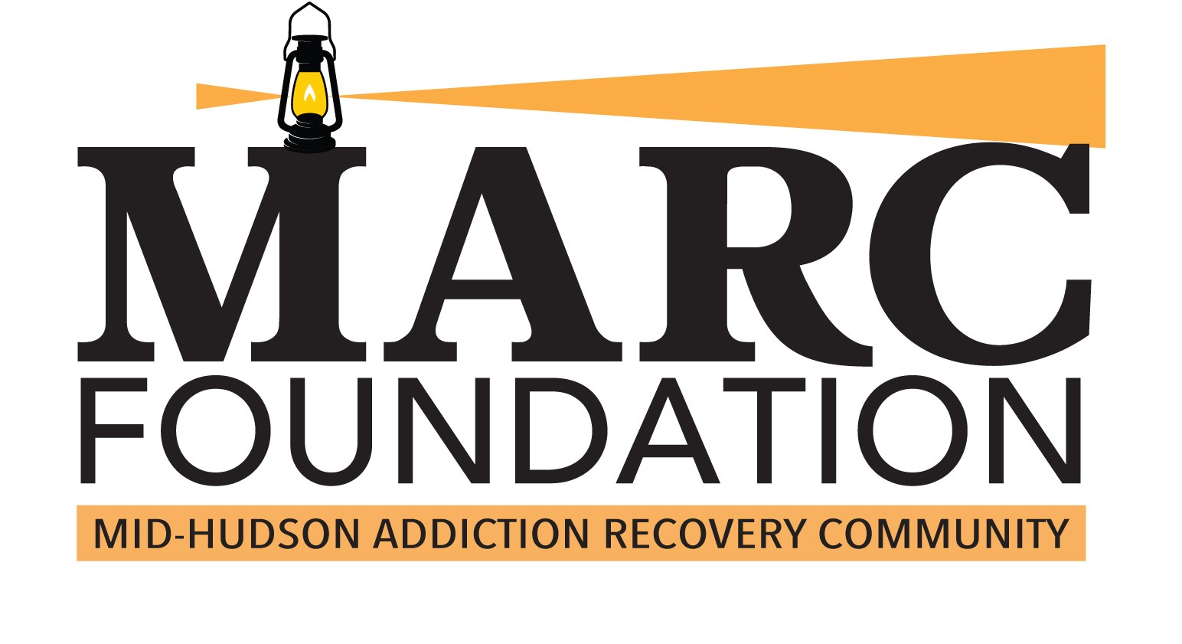

253 Mansion St Suite 301
Poughkeepsie, NY 12601
Phone (845) 505 3121
Fax (845) 473 4870 marc--foundation.org

Supporting
Addiction Recovery
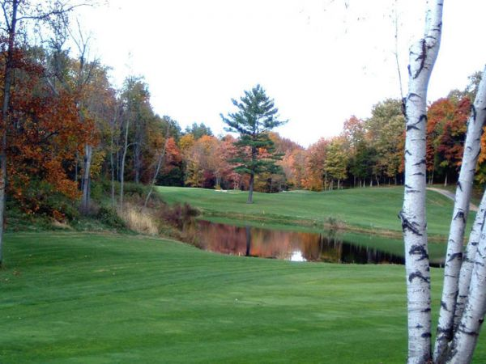

Tom Gannon/Cliff Andrews Day of Golf
Red Hook Golf Club
Thursday, August 20, 2019

Breakfast & Registration 8:00am
Lunch at the turn
Shotgun Start 9:00am
Dinner 2:30pm-4:30pm

EVENT PARTICIPATION
Golf tournament & hot buffet $125.00 Hot buffet only $50.00

Please check box
□ Number of Golfers______________
□ Number attending buffet only______
Name___________________________
Address__________________________
City, State, Zip_____________________
E-Mail___________________________
Phone___________________________
Sponsorship/Support Amount Enclosed $______________
Other Golfers Names
____________________________________________________________________________________________________________________________________
Buffet Only Names
____________________________________________________________________________________________________________________________________

sponsorship & SUPPORT

Please check box
Program Booklet Ad
□ Full Page $250
□ Half Page $125 □ Quarter Page $75 □ Business Card $25

□ Event Sponsor $2,000
Includes:
* Two foursomes for golf tournament * Event sponsor program recognition * Name and logo on welcome banner * Corporate Logo/Signage at tee * Your corporate information on tables * Full-page ad in event program

□ Banquet sponsor $1,250
Includes:
* Fee for four Golfers
* Corporate Logo/Signage
* Sign at tee; full-page ad * Two guest seats for hot buffet

□ Golf sponsor $ 600
Includes:
* Fee for two golfers
* Corporate logo/signage at tee; full-page ad
□ Tee sponsor $ 150
Includes:
* sign at tee; quarter-page ad

1st Hole-in-One wins a 2 yr lease on 2020 Nissan Sentra
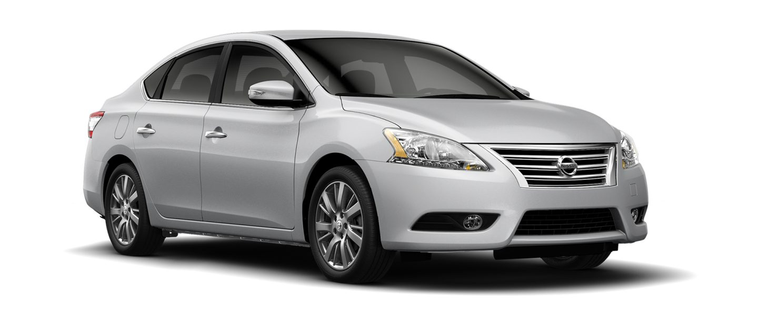

Sponsored by Kingston Nissan
Prize eligible for Amateur Registered Golfers only
Mail completed form and payment to:
MARC FOUNDATION
Attn: Nicole Taylor
253 Mansion Street
Poughkeepsie, NY 12601

Or visit our website:
www.marc-foundation.org
or Contact:
Mike Hawkins 845 661 0471
hawk3m@verizon.net
